FORMA GREEN USER GUIDE

1. **LOG-IN guide**

After typing the URL address in your browser, a log in page will be open to you

Depending on the privilege the user is having (admin or member) the user should chose fill in the require information that is user name and password

By default, the log-in form which is visible is that admin form but the user can switch to that of the member by clicking on the button indicating to where the member can log in

Figure 1.0 show and illustration of the admin log in screen

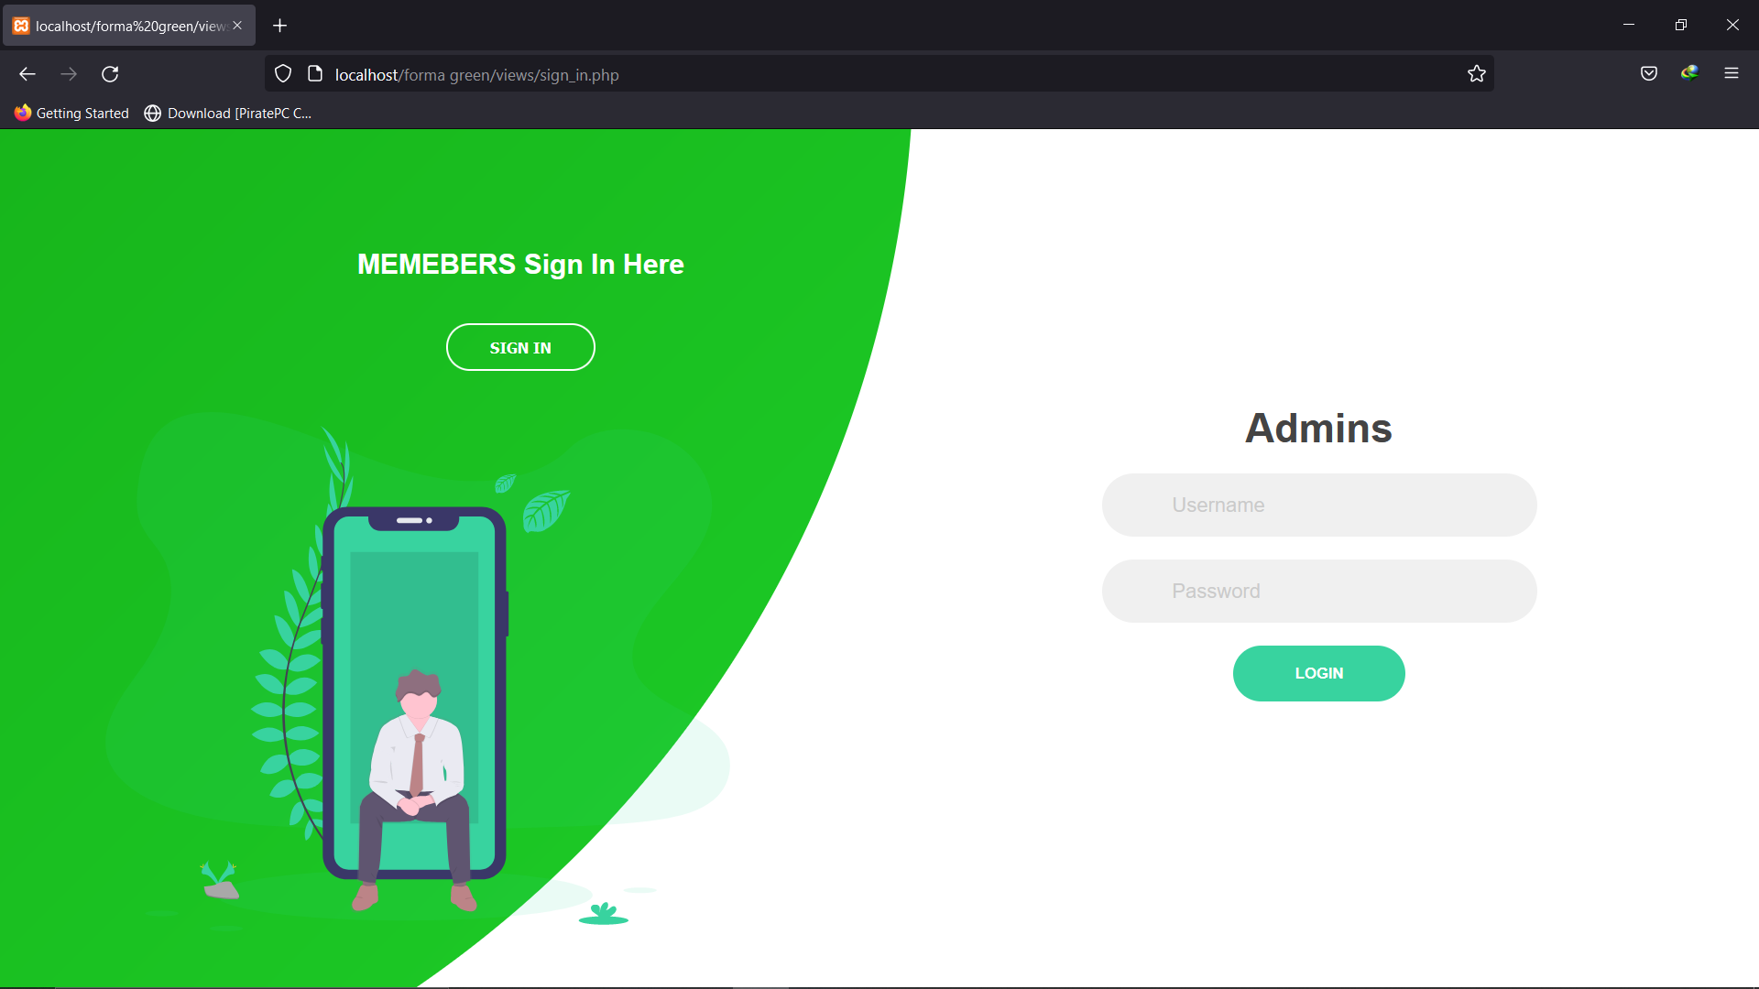

Figure 1.0 Admin log in page

As we can see the admin page require a username and a password to login from this page, we can switch to that of the member page by clicking on the button indicating **SIGN IN** just below the text **MEMBERS SIGN I HERE** at the top right of the page

Below is an illustration of the of the member sign in page

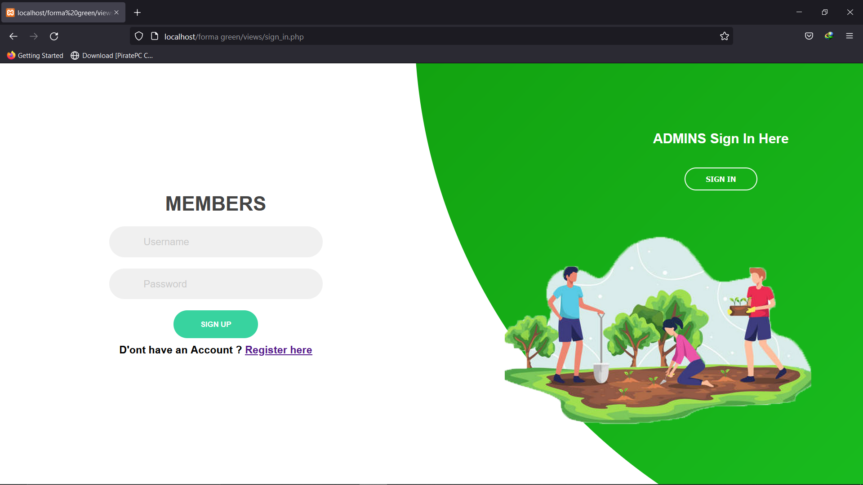

Figure 1.1-member sign in page

If a member does not have account and cannot get in touch with an admin to have one, he can directly create his own account by clicking on the Registration link just below the **SIGN-UP** button

A form will be display for him to create his own account. After registration the user can then sign up and connect his self to the application.

1. **Admin functionality**

**Below are some of the basic function of an admin.**

* Add a member (create a member account)
* Modify a member information
* Delete a member
* Add a green area for a user
* Delete green areas

1. **Add a member**

To add a new member the admin, click on the member button found on the navigation bar and a drop-down menu will show up he will see a add member button clicking on it will display a form the admin should fill in the form and should make sure to follow these precious rules

* Should not use a user name that pre-exists or a user name that is already being use by another member
* Should make sure to always tick the agree to all terms and services before submitting the registration form

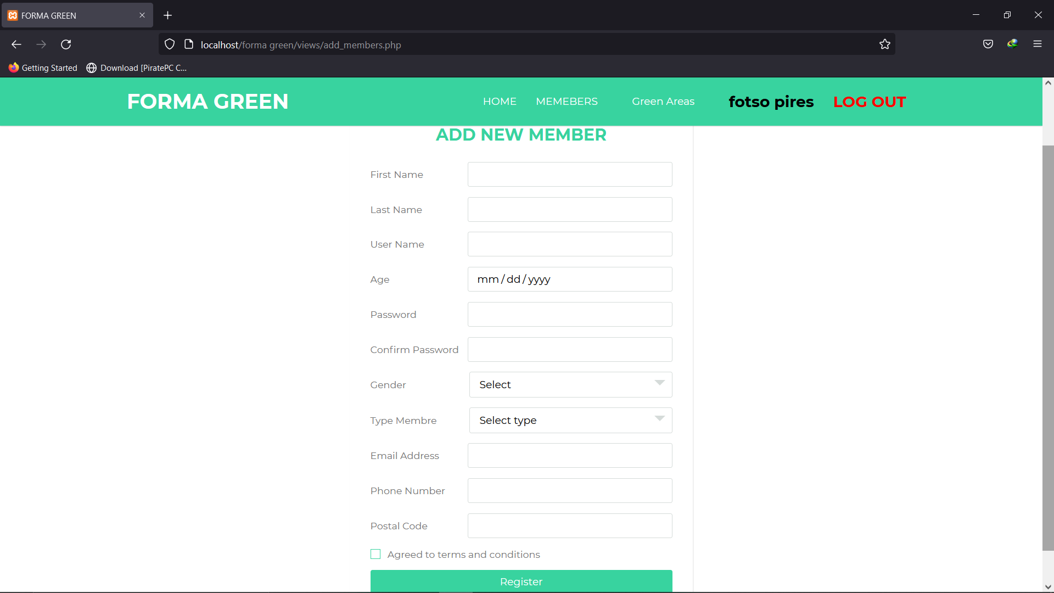

Figure 1.2 admin member registration form

1. **Modify a member**

To modify a member the admin should the admin should follow the same steps to add a member only that instead of clicking on the add member he should click on the all members button here all the member will be display with an edit and delete button by the side of all members the user should click the modify button and a modification form will be open to modify the user information

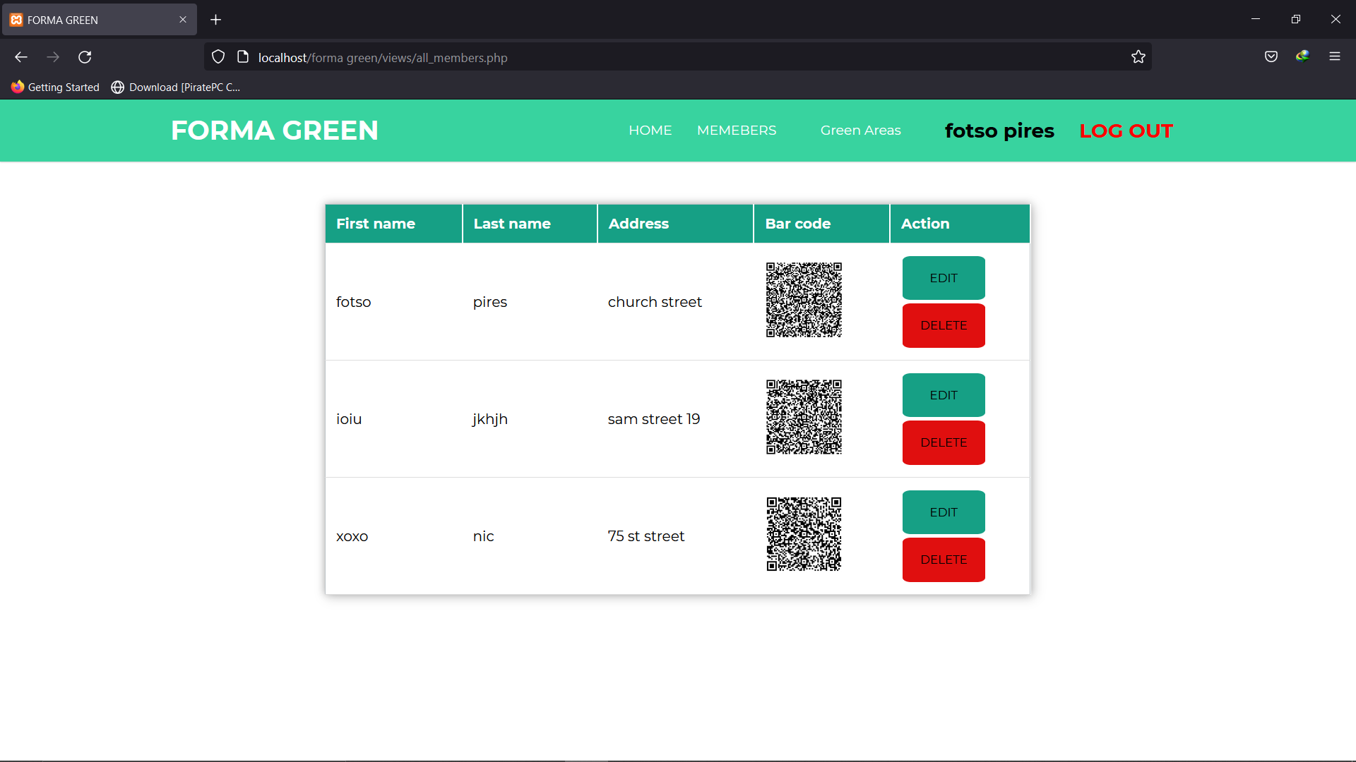

Figure 1.3 admin all member s viewing

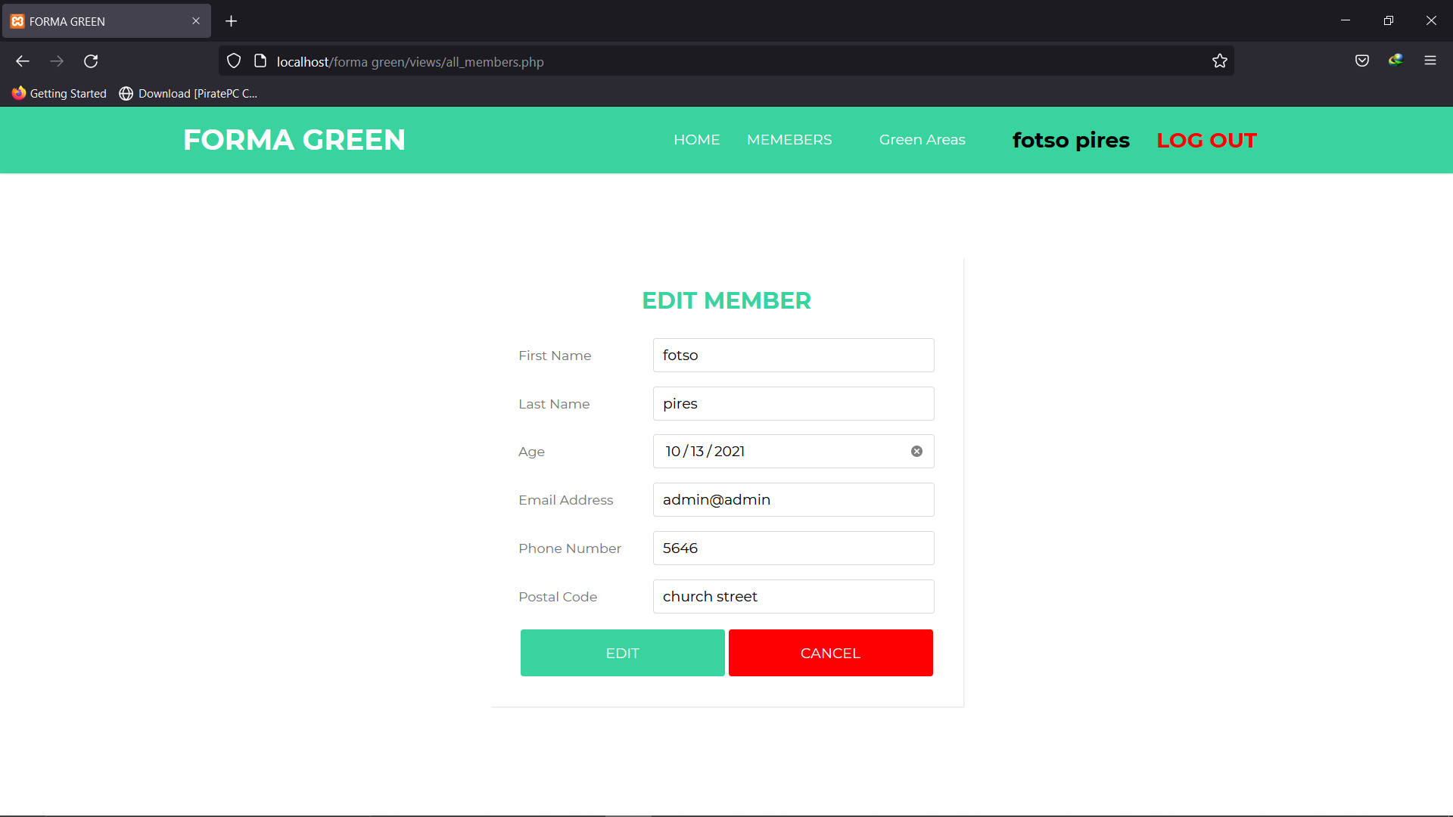

Figure 1.4 admin member modification form

1. **Delete a member**

To delete a member the user should click on the delete button corresponding to the user he wants to delete and a prompt form will be shown to him for confirmation of the deletion of the member

**NB:** to delete a member the admin should make sure to delete all the green areas corresponding to the member to be delete before for green areas cannot exist with a member that owns it and it may lead to crashing of the program

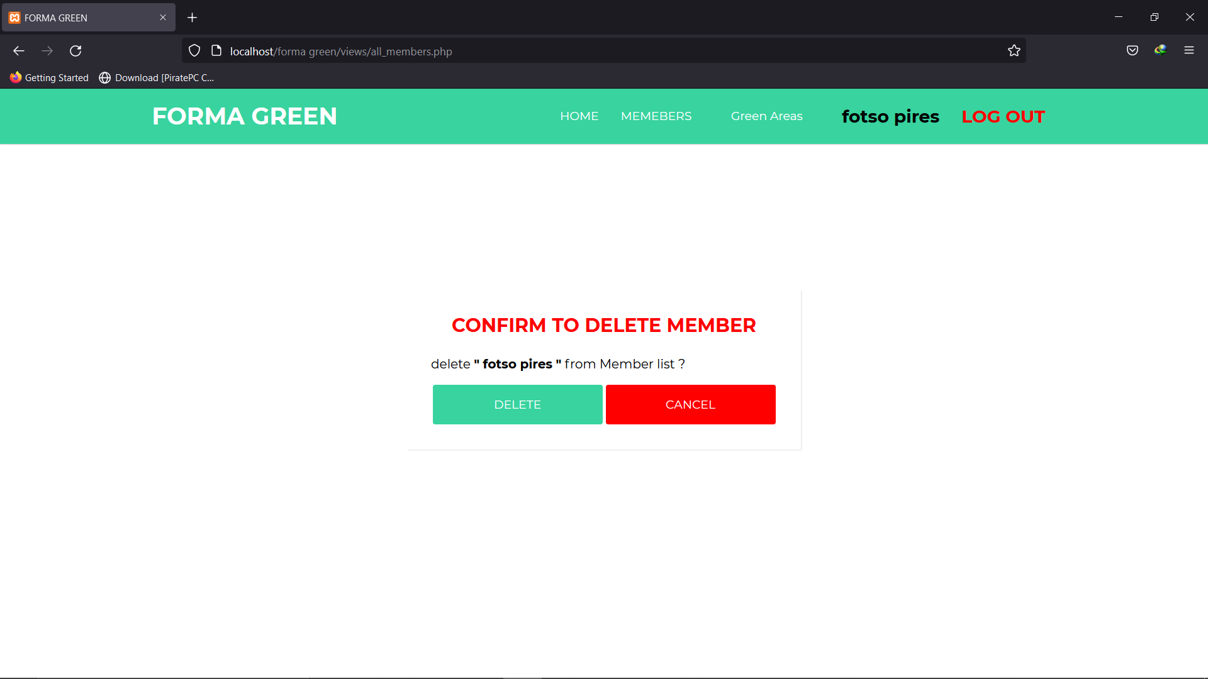

Figure 1.5 admin member deletion prompt message

1. **Add green Area**

To add a green area the admin, click on the green area button found on the navigation bar and a drop-down menu will show up he will see a add green area button clicking on it will display a form the admin should fill in the form and should make sure to follow these precious rules

* The admin should fill in the correct username of a member that exist (a member that already have an account)

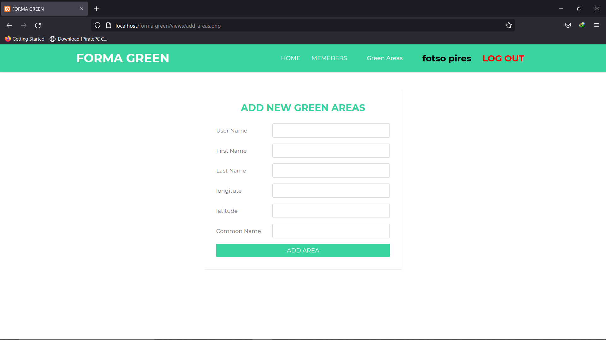

Figure 1.6 admin add green area form

1. **Modify green Area**

To modify a green area the admin to go to the view all green area on the nav bar found among the drop-down menu of the green area button

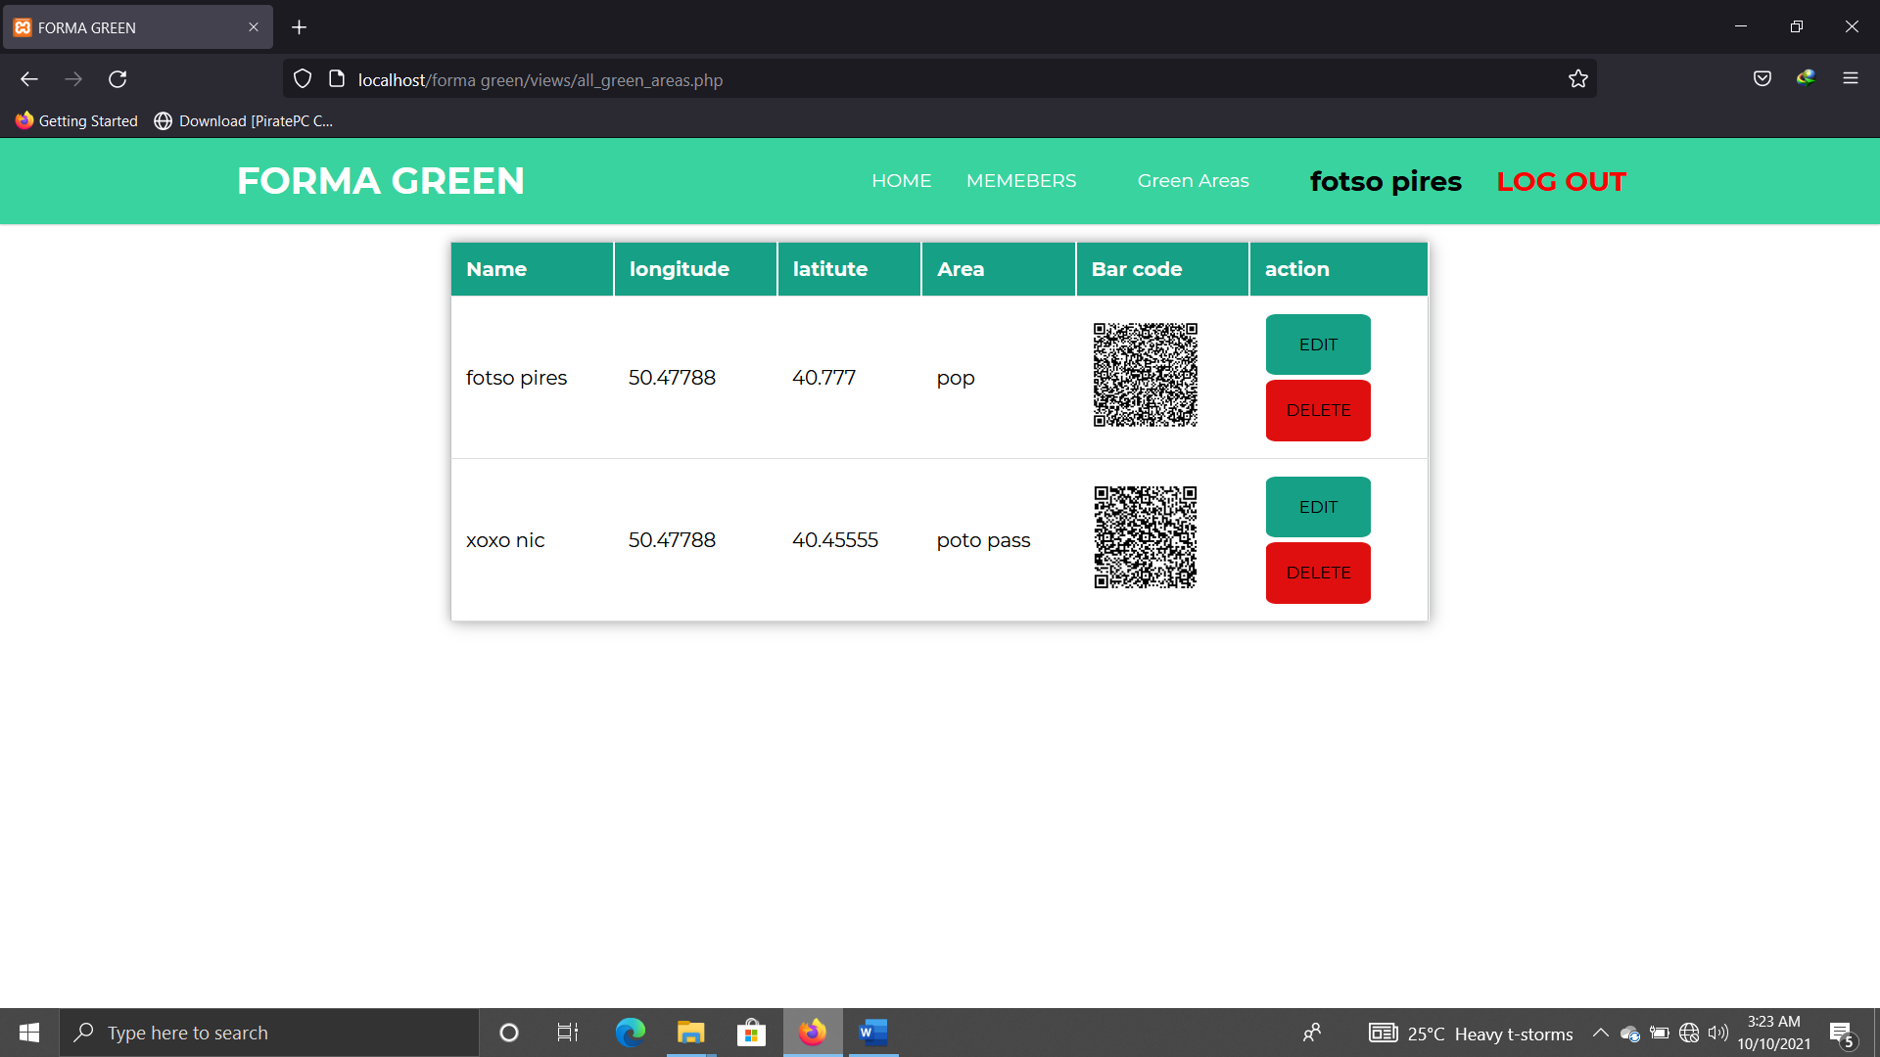

Figure 1.7 admin view all green area page

Then the admin clicks on the edit button corresponding to the green area he want to modify an a modification form will be opened to him after fill all the necessary in for of the green area he can submit the form for modification

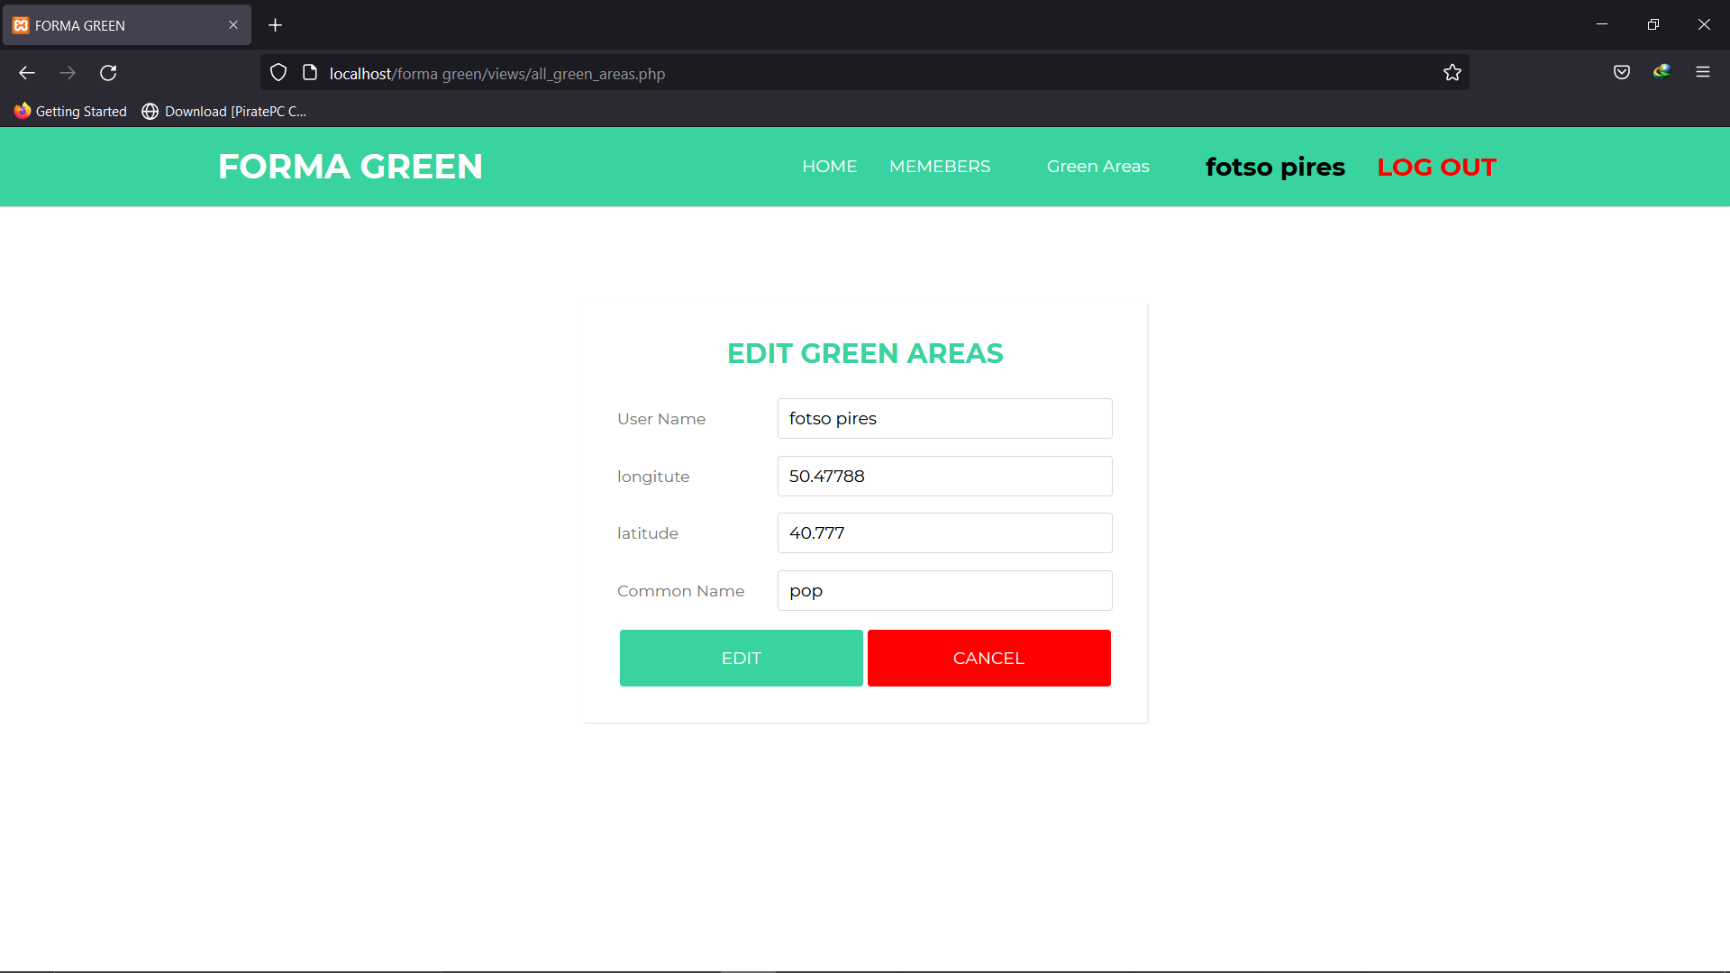

Figure 1.8 admin green area modification form

1. **Delete green area**

To delete a green area the admin, click on the delete button corresponding to the green area he wants to delete and a confirmation message will be prompt to the use after confirmation the green area will be deleted

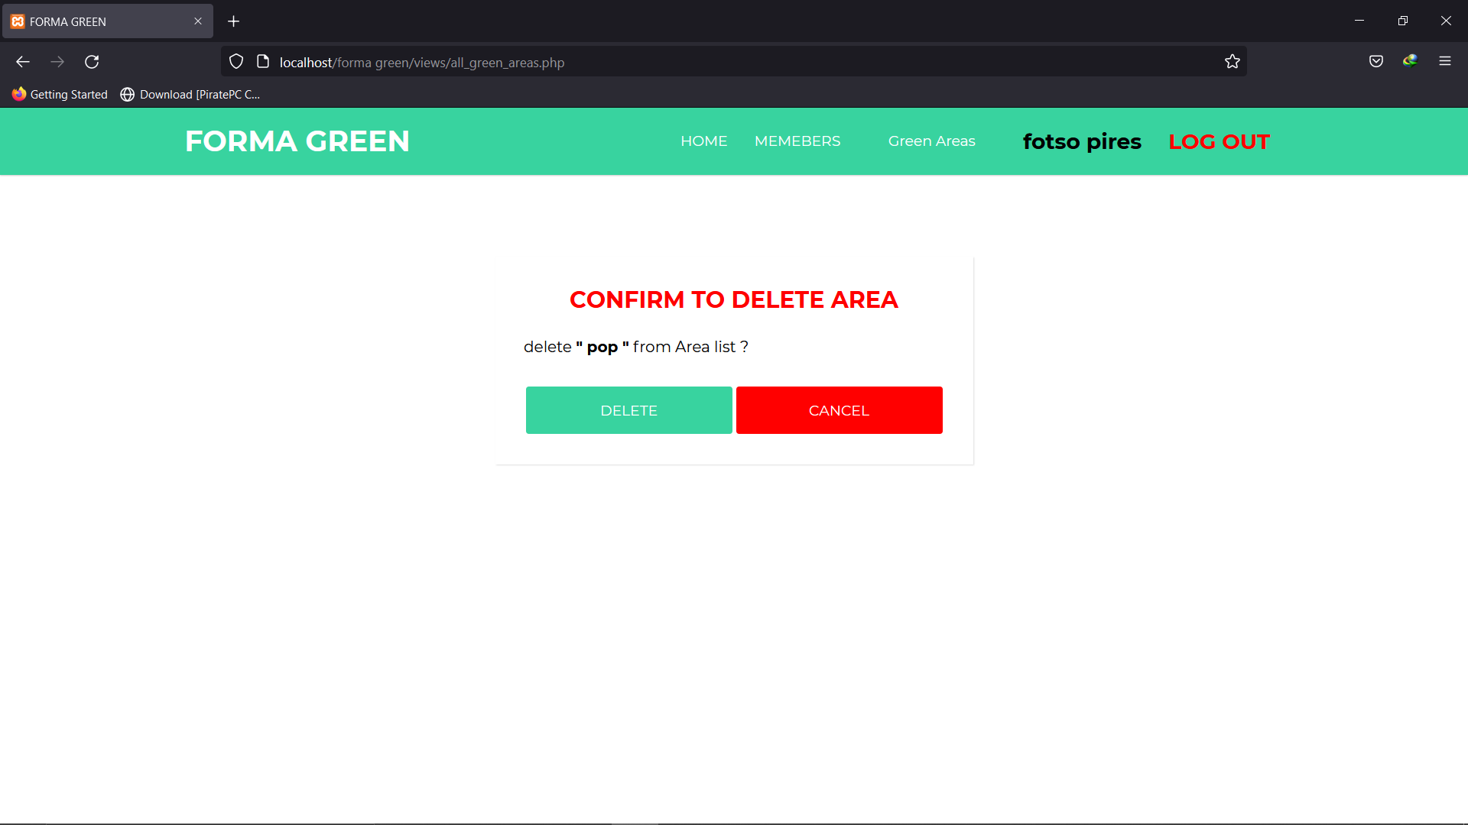

Figure 1.9 admin green area confirmation message prompt

1. **Member functionality**

**Below are some of the basic function of a member.**

* Subscribe
* Modify subscription
* Add a green area for a user
* Delete green areas
  1. **Subscribe**

After a member has create his account he can log in and subscribe to a length of time he will be a member of forma green

A newly added member has no subscription so when he will click on subscribe button found on the navigation bar, he will see a **“NO SUBSCRIPTION”** message and a subscribe button to subscribe the member simply click on the subscribe button to subscribe

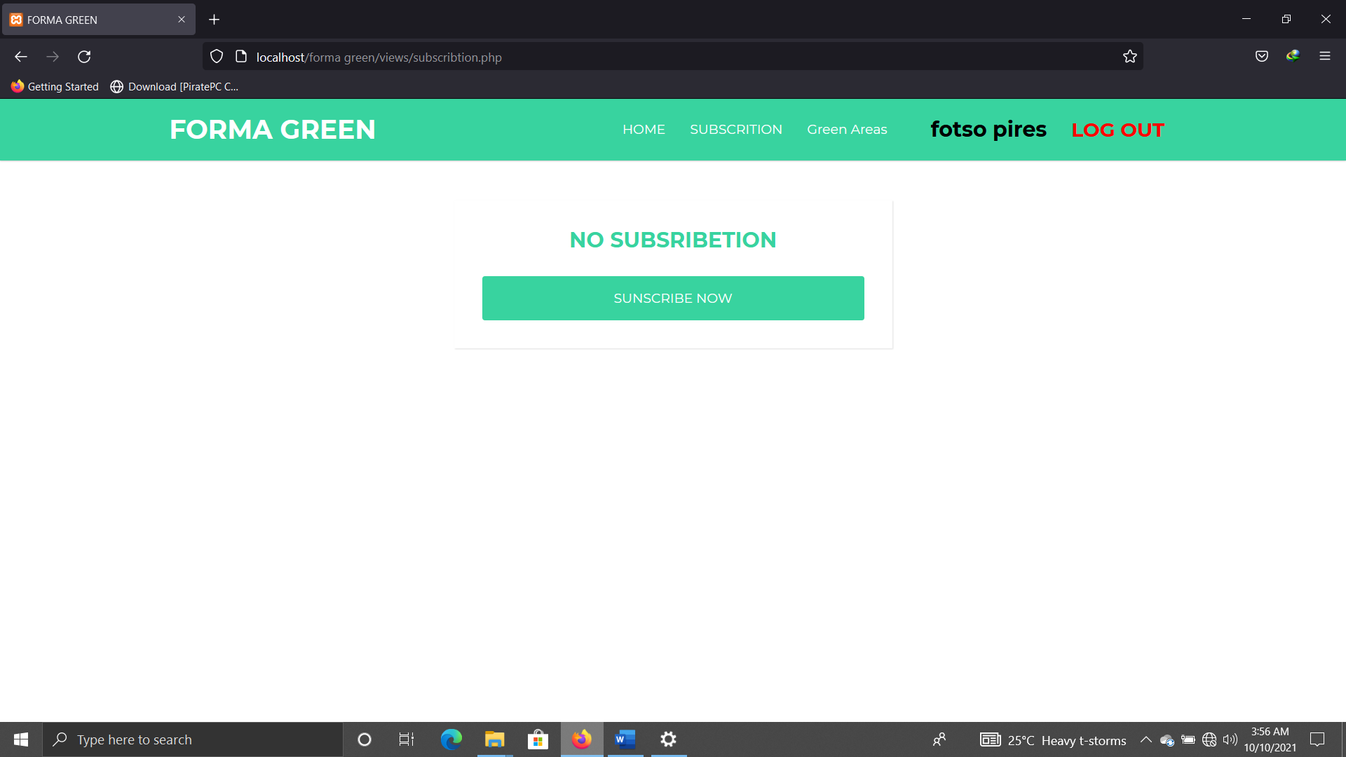

Figure 2.0-member subscription page with no subscription

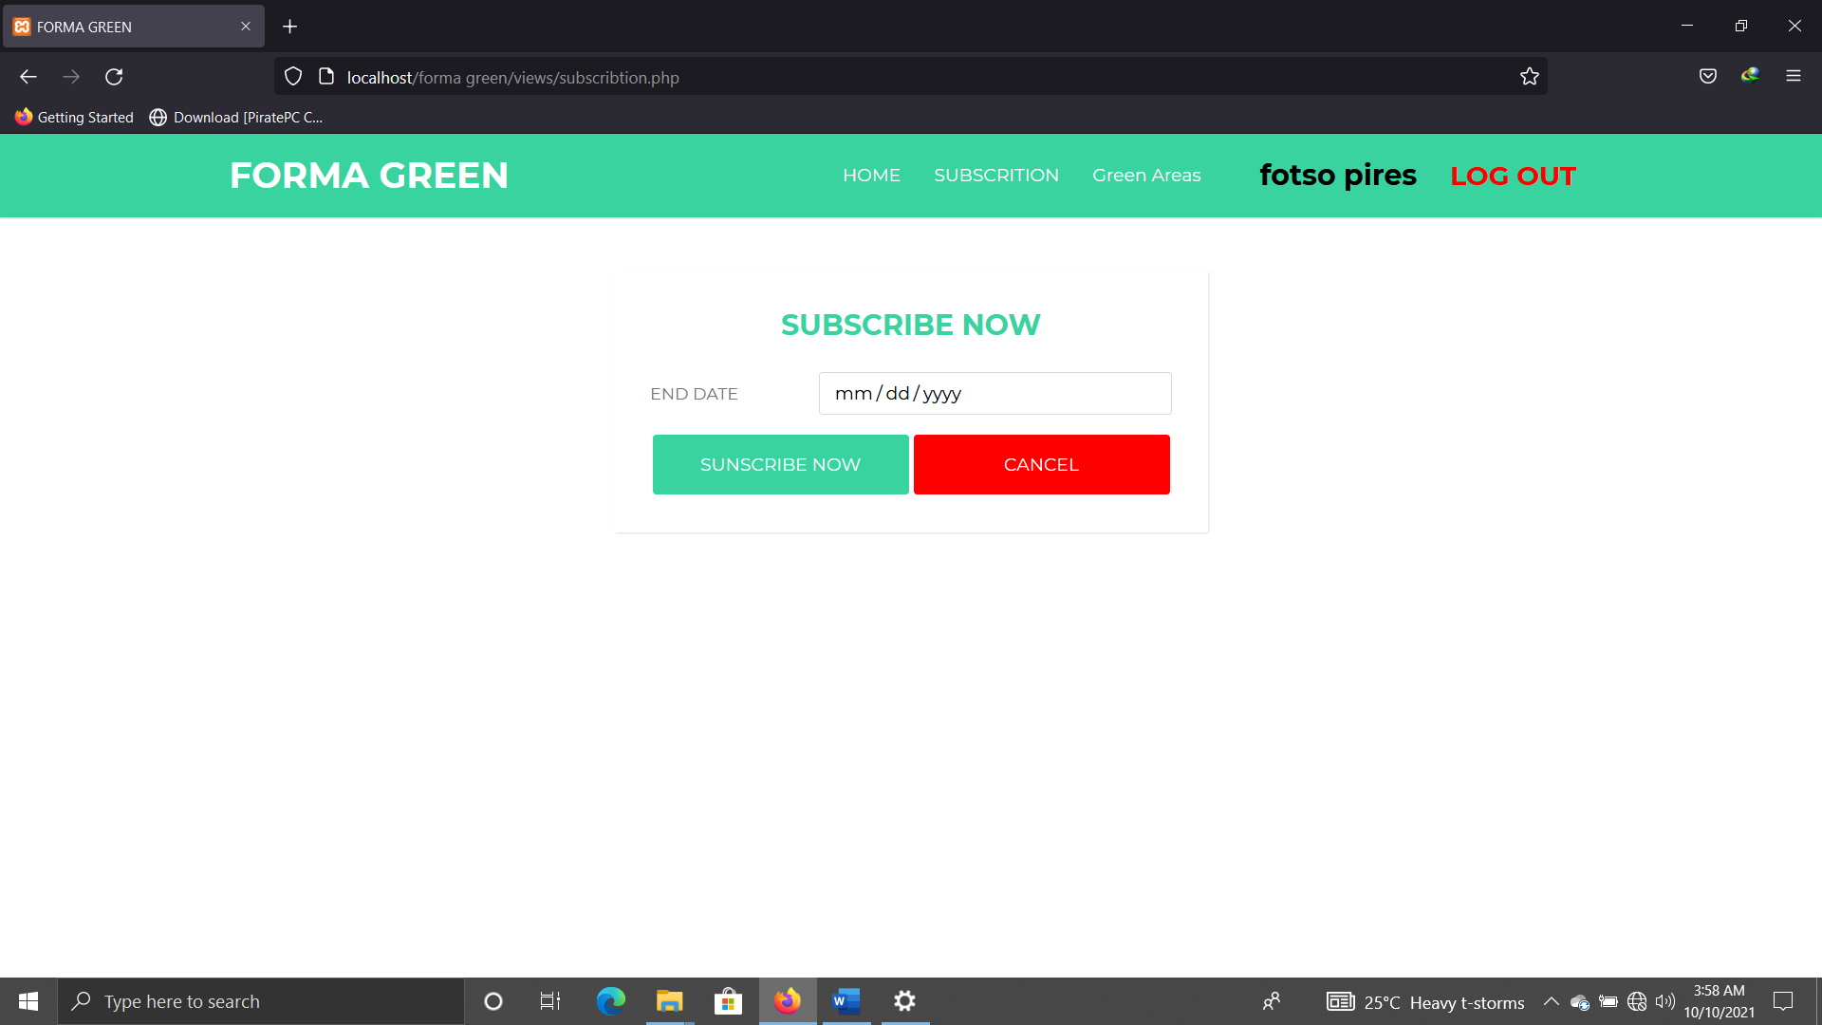

Figure 2.1-member subscription form

After the member has fill the for and decided the length of time he will be a member of forma green the subscription page will change showing him the length of time he is a member of forma green and display him two button one to extend his the subscription length and the other one to end the subscription

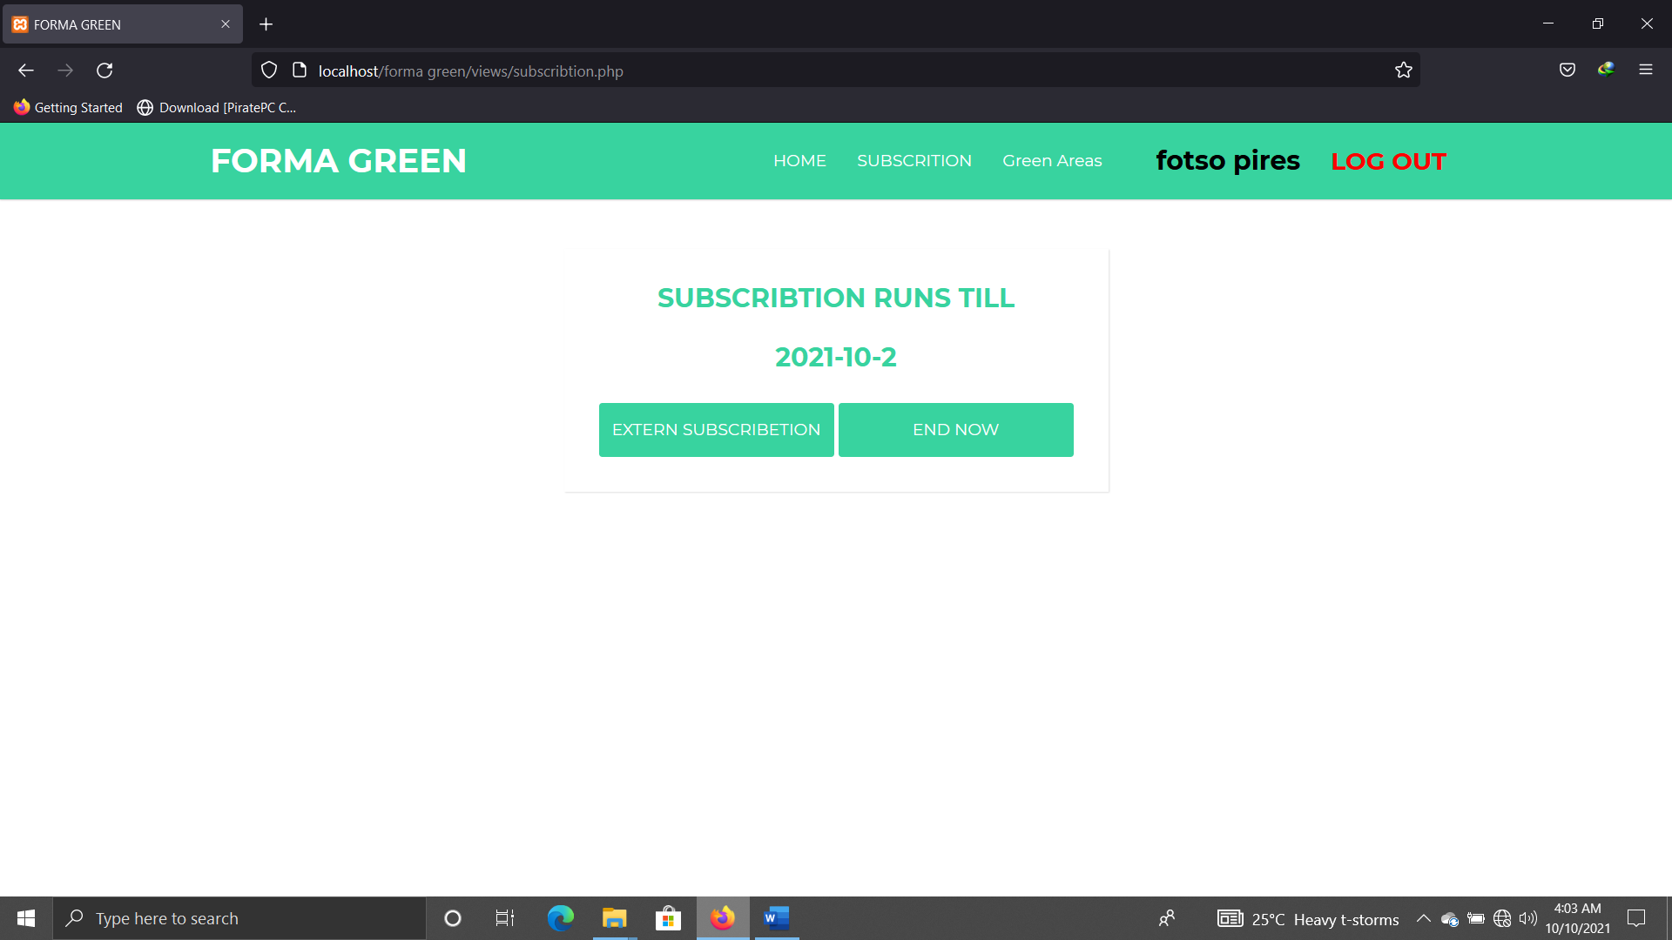

Figure 2.2-member subscription length

To modify or extern the subscription length the user clicks on the extern subscription button then a subscription extension form will be display to the member all the member will have to do is to edit the new length for the subscription

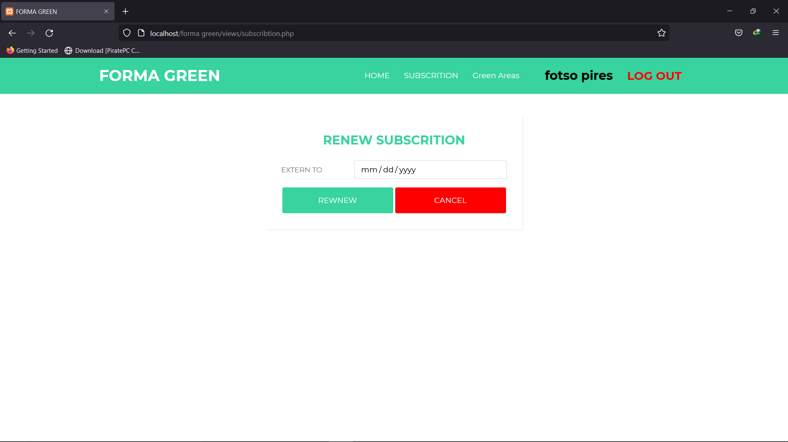

Figure 2.3-member renewing subscription length

To cancel or end the subscription the member clicks on the **END NOW** button and the subscription will be ended

To add and modify a new green area the member follows the same steps as the admin